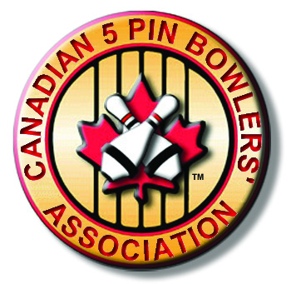
Canadian 5 Pin Bowlers’ Association

COACH
OF
THE
YEAR
Nomination

Elite Division

Recognizing excellence and dedication to coaching in the sport of 5 Pin Bowling

Dave Post

“Elite”

Coach of the Year

This award was renamed in 2011 to honour the dedication and commitment that Dave Post has made to advancing the art of coaching 5 Pin Bowling.

- Annual award for Provincial coaches.
- Special recognition for all coaches.
- The Elite Coach of the year award is based on performance during the bowling season (2012-13)
- All current coaches are eligible.
- Show pride and respect for your coaches.
- Elite coaches will receive points based on the following:

- C5PBA events (local to National level)
- MBAC events (local to National level)
- YBC events (local to National level)
- Medalists at championships

Please complete the following profile as thoroughly as possible. Nominations MUST be submitted through, and approved by, your Provincial 5 Pin Bowlers’ Association (Prov 5PBA). ONLY ONE NOMINEE PER PROVINCE WILL BE ACCEPTED. The following will assist in ensuring you give adequate time to complete this process.

Submitted to Local 5 Pin Bowlers’ Association by: (optional) ________________

Submitted to Provincial 5 Pin Bowlers’ Association by: October 1, 2013

Submitted to Canadian 5 Pin Bowlers’ Association by: December 31, 2013

Award recipients will be announced at the C5PBA Semi-Annual General Meeting in January for the previous bowling season.

You may use the back of this page or a separate letter to indicate why you feel this coach is a worthy candidate for the C5PBA “Dave Post” Coach of the Year Award.

(cont. over)►

Nominee: ______________________________

Background:

___________________________________________________________________________
___________________________________________________________________________

___________________________________________________________________________
___________________________________________________________________________
___________________________________________________________________________
___________________________________________________________________________
___________________________________________________________________________
___________________________________________________________________________
___________________________________________________________________________
___________________________________________________________________________
___________________________________________________________________________

___________________________________________________________________________
___________________________________________________________________________
___________________________________________________________________________
___________________________________________________________________________
___________________________________________________________________________
___________________________________________________________________________
___________________________________________________________________________
___________________________________________________________________________

PLEASE COMPLETE THE COACH PROFILE

COACH PROFILE

NOMINEE INFORMATION: NOMINATED BY:

Name: _____________________________ Name: ________________________
Address: ___________________________ Address: ______________________
City/Prov: ___________________________ City/Prov: ______________________
Postal Code: _________________________ Postal Code: ____________________
Phone: ( ) ________-________________ Phone: ( ) ________-___________
CC#: ________________________________
C5PBA#: _____________________________

1 2012-13 COACHING in Prov 5PBA and C5PBA Tournaments (e.g. Youth Challenge, Open )

Tournament Canadian Open

Provincial ______

Medalist at Provincial Championship: Gold ____ Silver ____ Bronze

National; ____________

Medalist at National Championship: Gold ____ Silver ____ Bronze ____

Tournament Youth Challenge

Provincial ______

Medalist at Provincial Championship: Gold ____ Silver ____ Bronze

National; ____________

Medalist at National Championship: Gold ____ Silver ____ Bronze ____
___________________________________________________________________________________________

2 2012-13 COACHING in MBAC programs.

Medalist at National Championship: Gold ____ Silver ____ Bronze ____

3 2012-13 COACHING in YBC program

Coach of YBC 4 Steps to Stardom

Provincial ______

Medalist at Provincial Championship: Gold ____ Silver ____ Bronze ____

National ______

Medalist at National Championship: Gold ____ Silver ____ Bronze ____

